BotVault

WHO: David & Jun
WHAT: Final Project
WHERE: CSC318
WHEN: Due by course completion
WHY: Show understanding of SDLC and design principles

PURPOSE: Create a Desktop Application for Microsoft Windows systems that acts as a “vault” for trading bot information.

Features: Bot Library, Performance/Validation Tracking, Version History, Note Section

Actors: Trader(User)
Developer

Use Case:
- Add Bot File
- Delete Bot
- Search/Filter Bots
- Manage Versions
- Store Performance Metrics
- Export Bots
- Tag Bot Status

Functional Requirements:
- Create bot metadata; think hashing
- Attach the bot code
- Be able to pull out the code
- Edit bot attachments
- Delete a bot
- Search and filter bots
- Sort bots?
- Display bot data (pop up box)
- Tag bots for status (in development, finished, etc)
- Store multiple versions of bots
- Persist all data locally using NoSQL

Non Function Requirements:
- Performance: Search across bot library provides results in under 500ms
- Usability: Able to upload a bot with its code in under 5 clicks
- Integrity: Stored bots are verified against hash
- Portability: Can run on Windows 11/10
- Availability: Has availability without any internet connection
- Recoverability: User can export vault

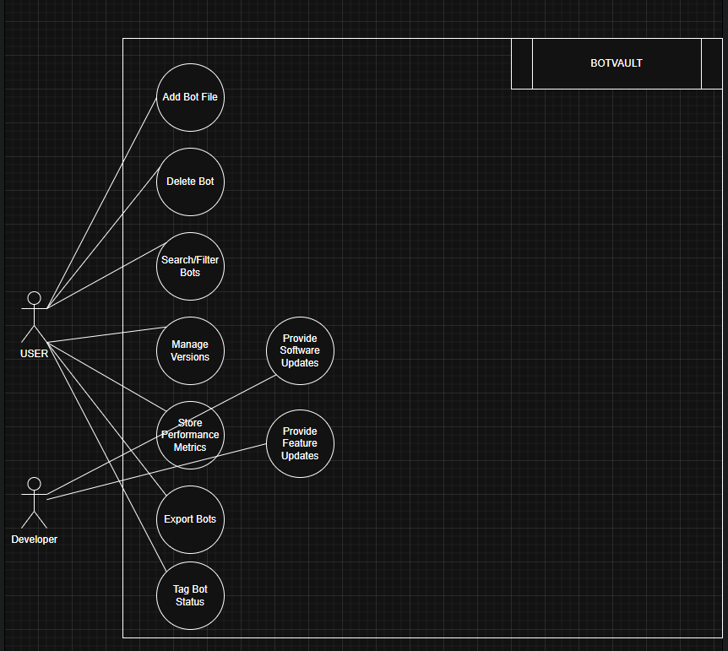

ERD diagram of SQL
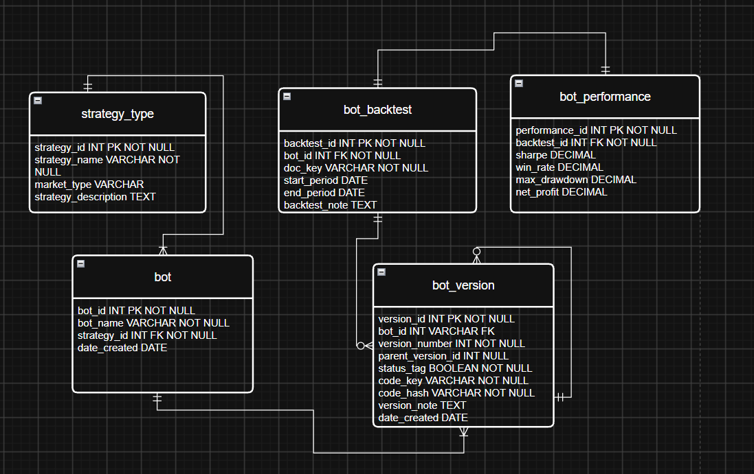

- Strategy table will hold data such as discretionary, non-discretionary, forex, futures, stocks etc
- Bot table will hold simple data regarding the bot
- Bot_version table will hold the version number, code_key is NoSQL key to retrieve code, status (whether its running or not), code_hash is the integrity digest used to verify corruption or duplication.
- Bot_backtest table will hold the doc_key for retrieving backtest documents from NoSQL and descriptive data.
- Bot_performance will hold key metrics regarding a backtest.

SQL database – SQLite
NoSQL database – LMDB
Both databases has python library or package.

